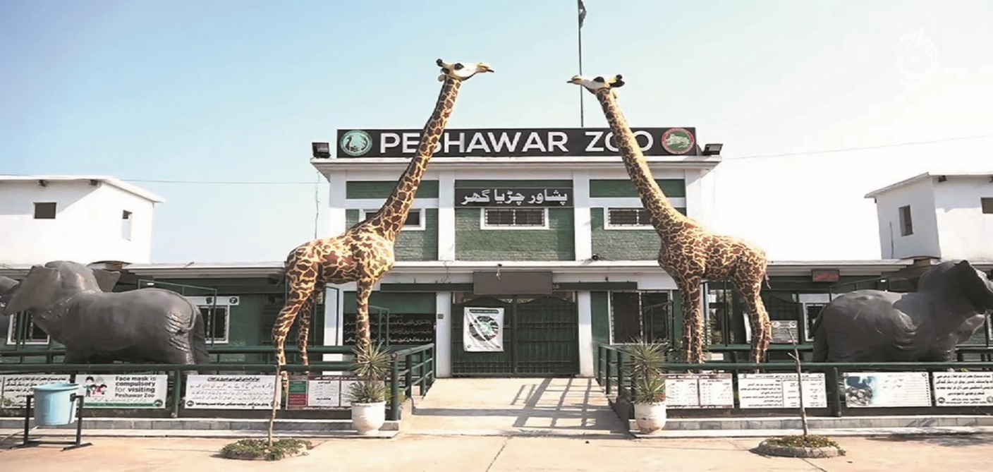

About Peshawar Zoo Park

What is Peshawar Park Zoo? and where is located established?

The Peshawar Zoo, officially known as Peshawar Wildlife Park, is located in Peshawar, the capital city of the Khyber Pakhtunkhwa province in Pakistan. It is one of the relatively new zoos in the country, offering both recreational and educational experiences for visitors The zoo is situated in Shahi Bagh, near the center of Peshawar, making it easily accessible to residents and tourists. It is close to other key landmarks within the city The Peshawar Zoo was established in 2018, making it a modern addition to the city’s attractions. It was part of the government’s initiative to promote wildlife conservation, education, and recreation.

Opening & Closed Timings

Opening Time: 9:00 AM To Closing Time: 6:00 PM

Usually around 5:30 PM, so visitors have enough time to explore before the zoo closes.

The Peshawar Zoo does not have specific "ladies-only" or "family-only" timings, and it is open to all visitors, including families and women, during its regular hours.

There are no specific "Ladies' Days" listed in the zoo's schedule. For information on special events, it's best to check the zoo's official website or contact them directly.

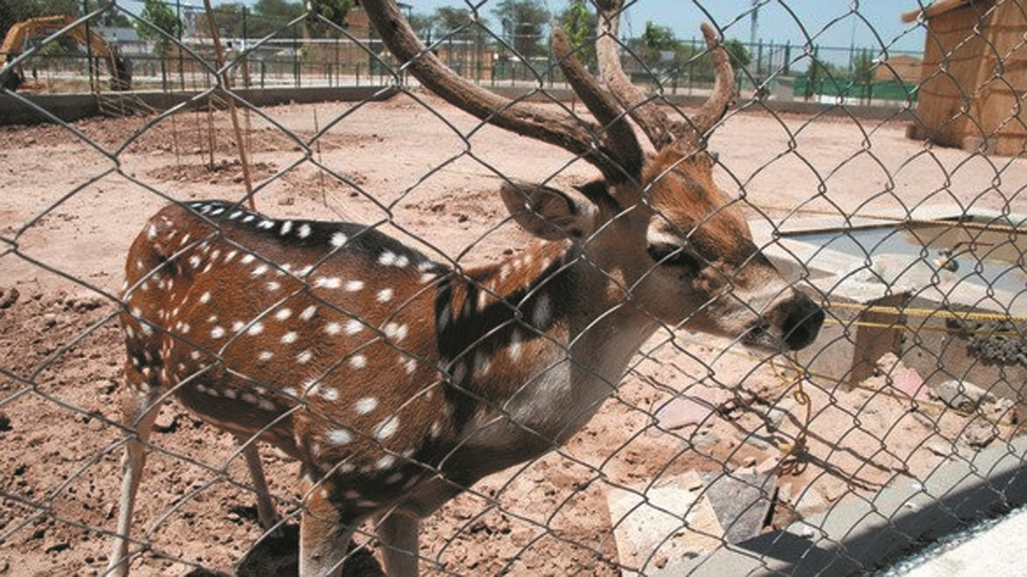

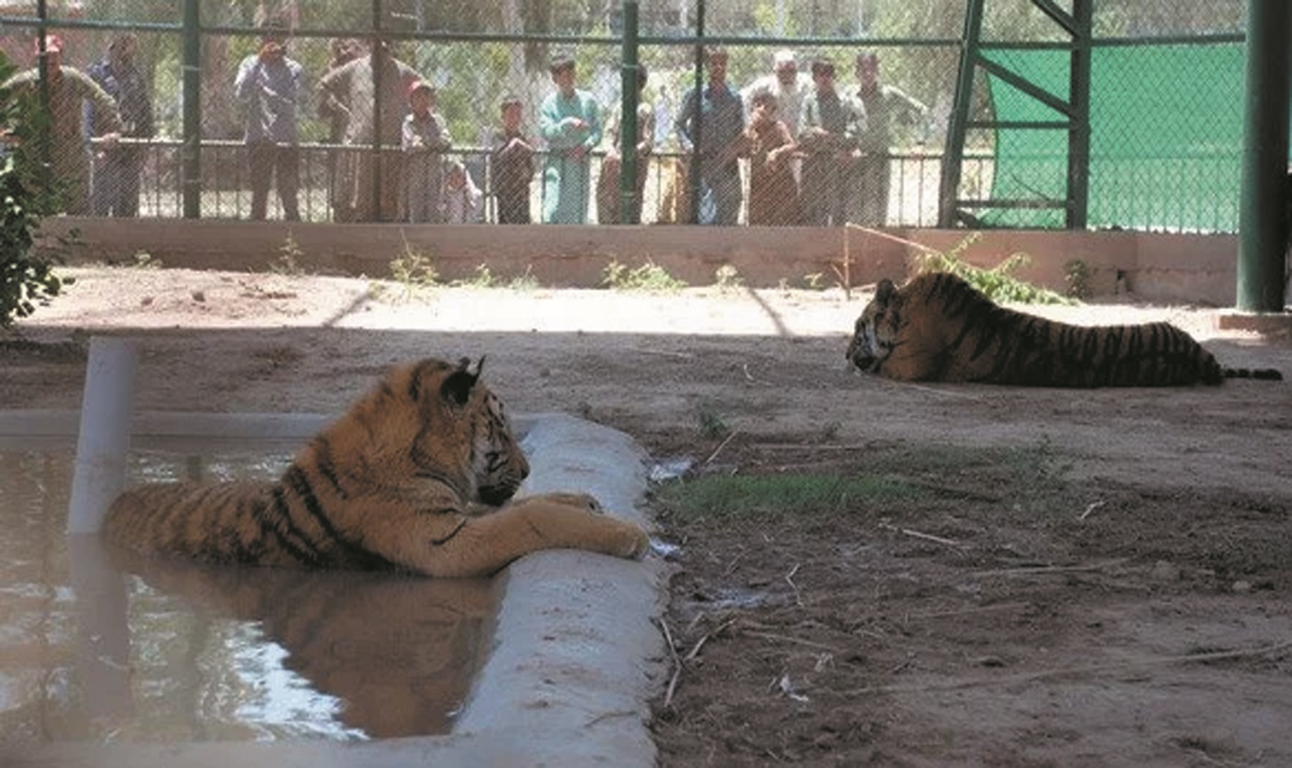

Animals List

The Peshawar Zoo is home to around 100-150 animals, representing over 30 species. Since its establishment in 2018, the zoo has been growing, and it is focused on the conservation of both native and exotic species.

Notable exhibits include:

Lions

Bear

tigers

Turtle

Crocodiles

Snakes

Deer

Snow leopard

Monkeys

Address & Contact

Address: Shahi Bagh, Peshawar, Khyber Pakhtunkhwa, Pakistan the zoo is located near the city center of Peshawar. For questions related to visiting, opening times, directions, accessibility, or other general information, you can visit their [Support Centre](https://wildlife.kp.gov.pk).

Email: For specific enquiries

you can fill out the contact form available on their (info@wildlife.kp.gov.pk).

Phone: For urgent enquiries, you can call their Supporter Contact team at +92 91 9215388.

For the most accurate and up-to-date information, it's recommended to visit the [official Peshawar Zoo website](https://wildlife.kp.gov.pk).